Master slave concept

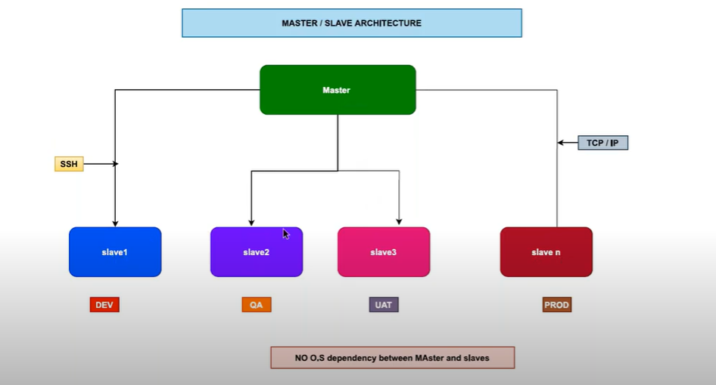

. 1st we need to install Jenkins master server

. Slave / node🡺install another server 🡺we need to create node / slave

> The main purpose of master and salve is distributing the builds.

🡺 Jenkins 🡺lot of jobs create 🡺load increase🡺more cpu / memory / network utilization increase🡺Jenkins instance🡺hung state.

. To over come this master / slave concept came into the picture.

. By using master / slave concept 🡺 we will create the in Jenkins master and that jobs are build in nodes.

. The communication between master and slave is SSH.

. The communication between master and slave protocol l is TCP/ IP.

. Key point:-1. We need to install Jenkins in master only.

2. We need not to install Jenkins on slave / nodes.( only java install).

3. Basic rule:-java must be installed

. Master instance🡺 only one instance

. Nodes will be n no.of instances.

. 🡺 In real time each node can be treated as one environment.(Dev, qa, uat, prod.)

. Each node 🡺 tomcat instance.

. 🡺 The jobs are running between master / slave by using labels.

. No operating system dependency between master and slaves /nodes.

. Jenkins🡺Linux and nodes🡺windows, centos, debian,…etc…

Step:-1

. launching two servers (master and slave)

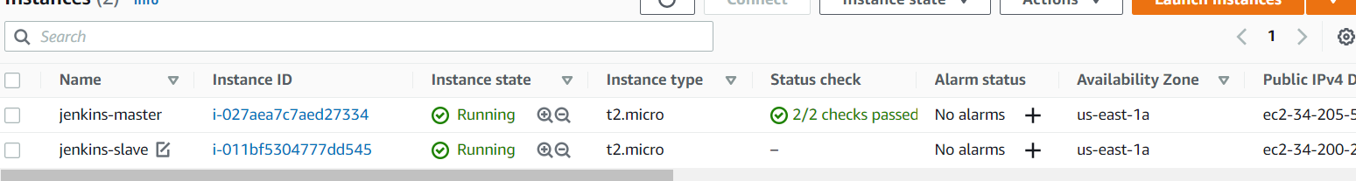

Step2:-

We need to login both servers

. install jenkins server to launch Jenkins package, and slave server only install java

Step3:-

. go to jenkins dash board🡺create slave

. manage Jenkins🡺manage nodes and clouds🡺click on new node🡺create

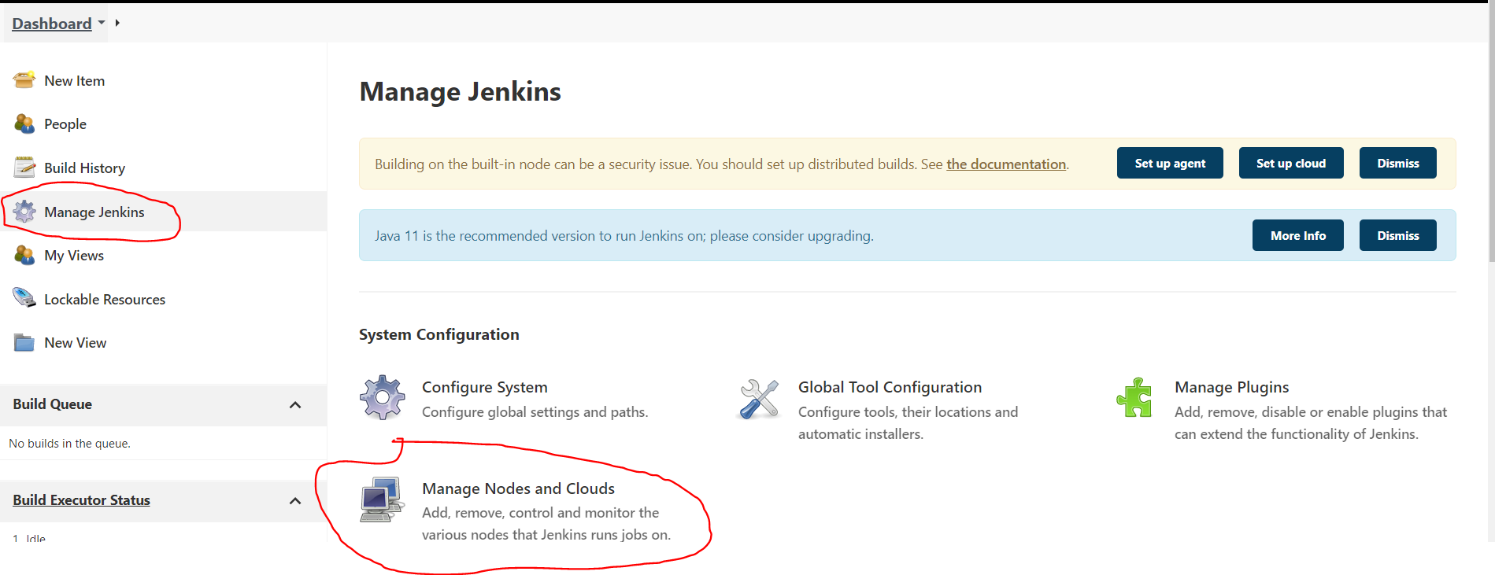

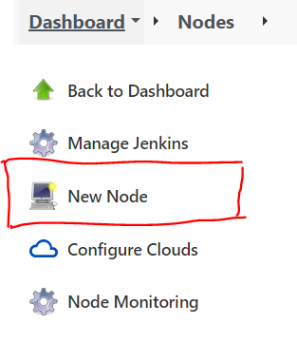

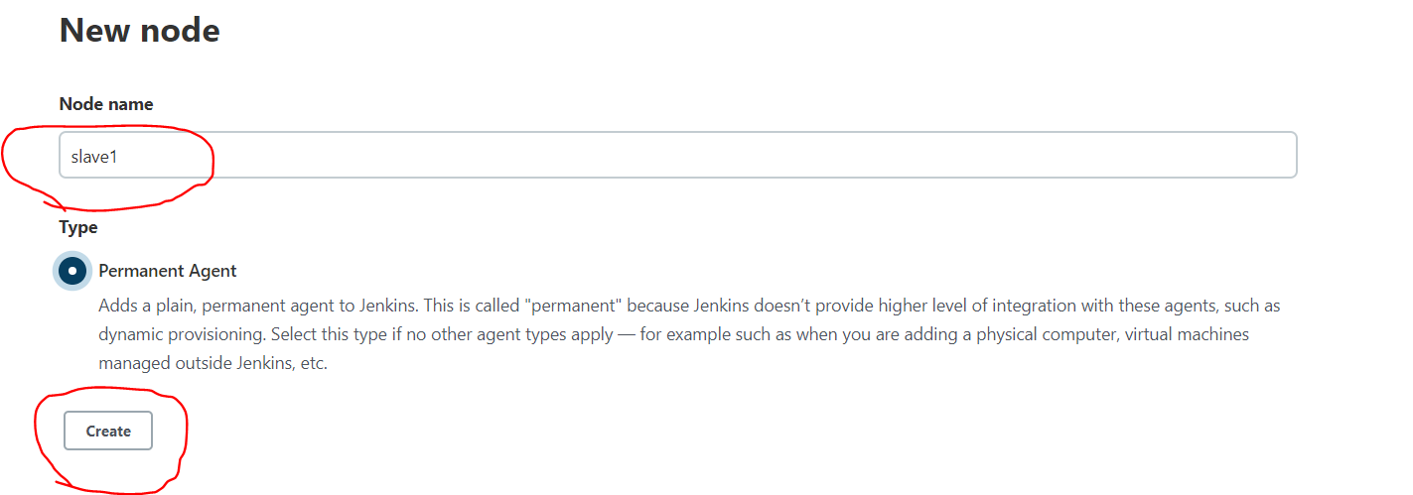

Remote root directory:- slave workspace by automatically create creating

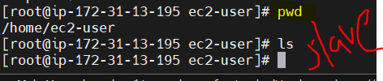

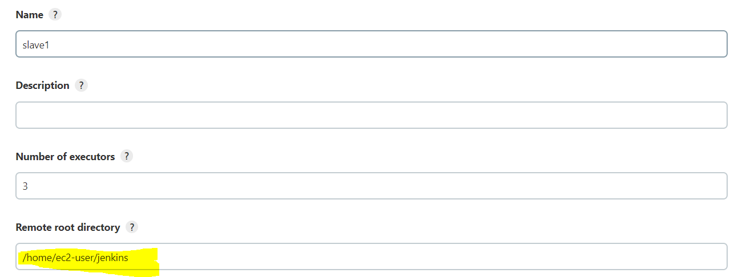

Labels:- jobs will run if the labels match.

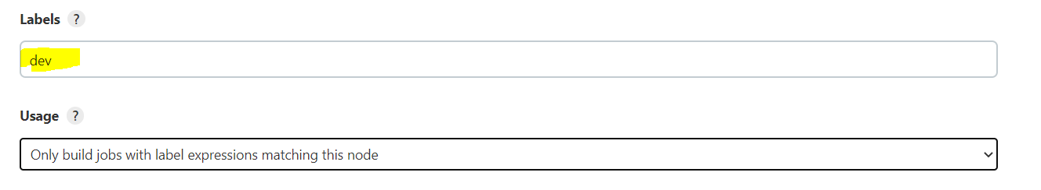

Ssh:- the communication b/w master and slave ssh config.

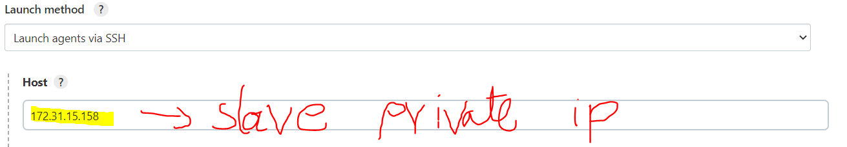

Credentials:-



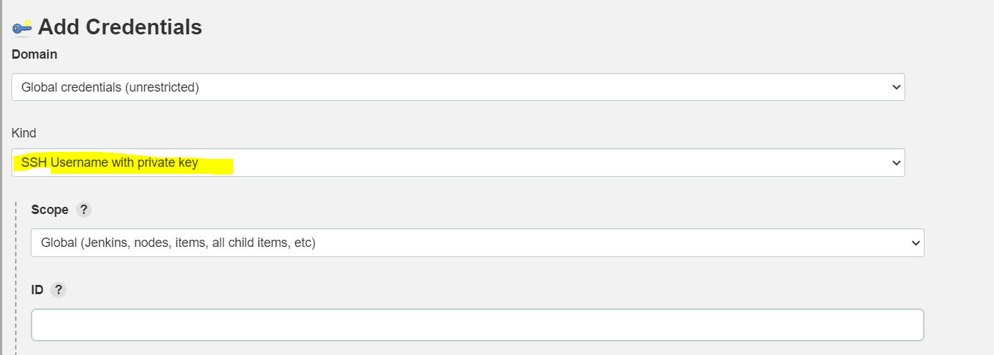

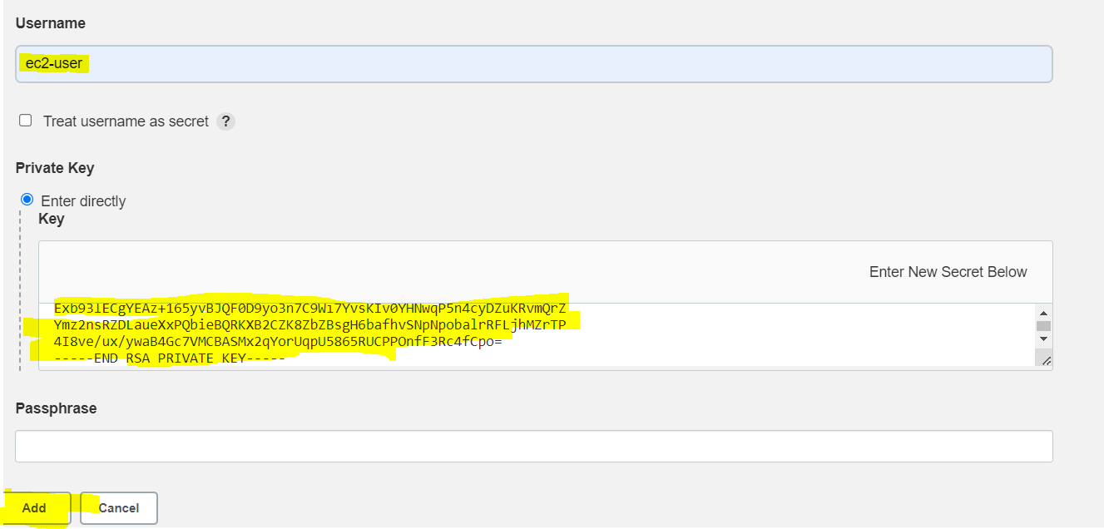



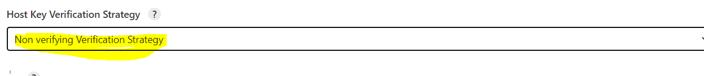

. master and node attach complete.

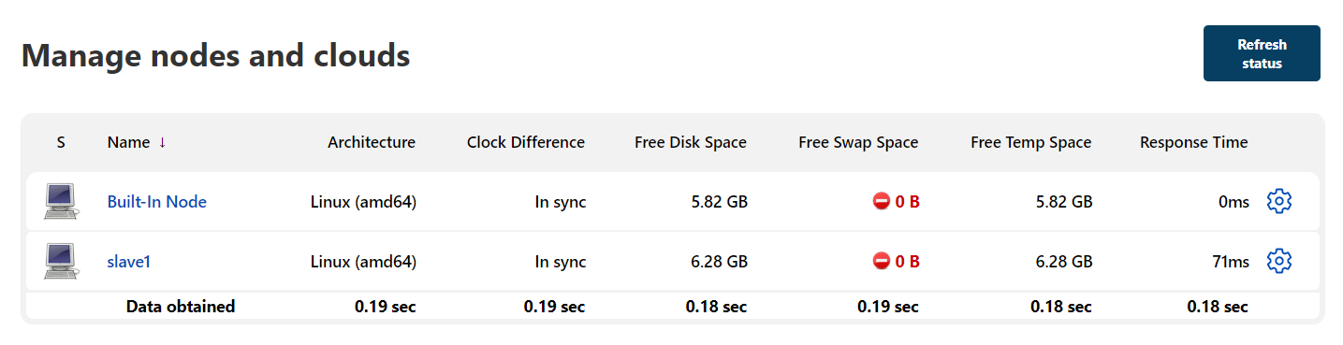

. go to slave server

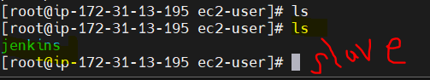

. there is no jobs running in jenkins master

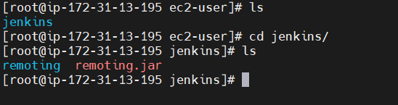

. create a job🡺go to Jenkins dash boad🡺click on new item🡺create freejob🡺I am executing small shell command

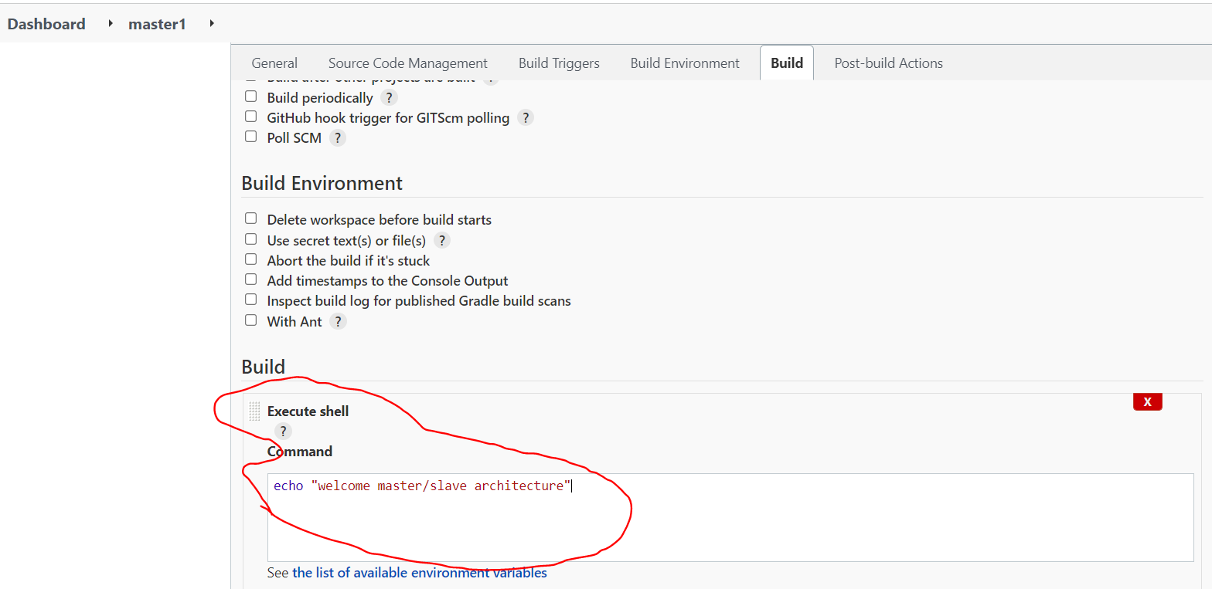

. go to general🡺select restrict(because job created on master but run job on node(master🡺node))🡺label🡺apply and save.

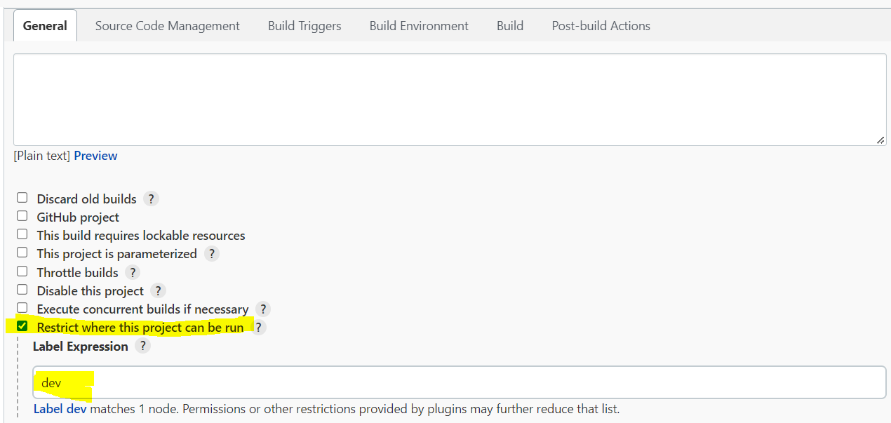

. build now

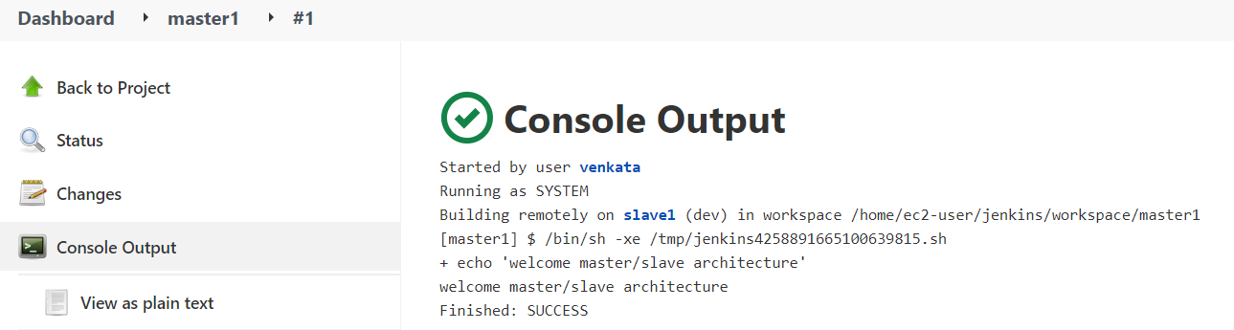

. go to slave check

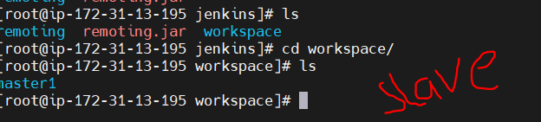

Ex2:-

. I am creating another job (automation project)

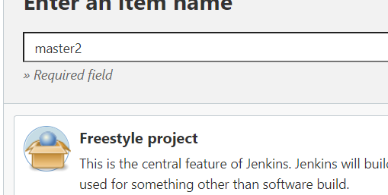

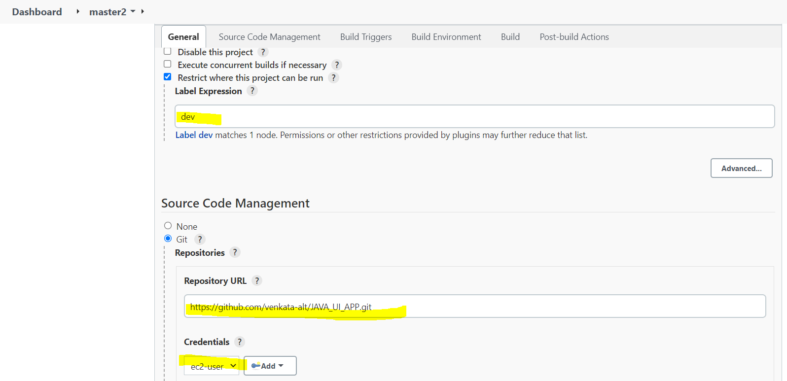

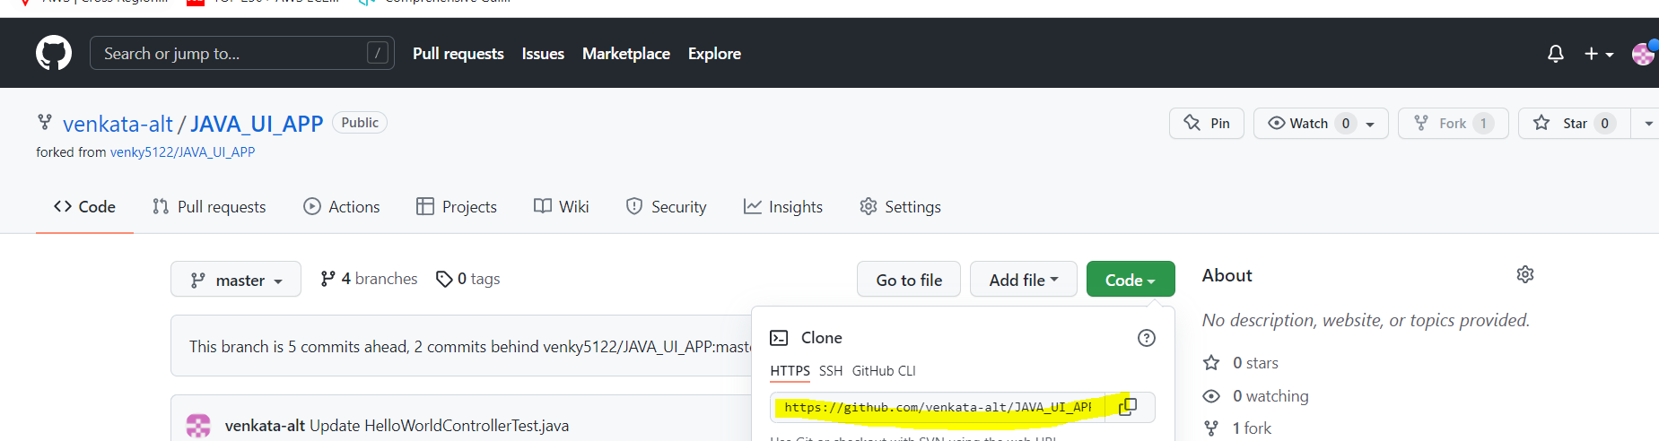

. apply and slave🡺build now🡺build failed🡺because we don’t install git on slave server🡺install git🡺again build now 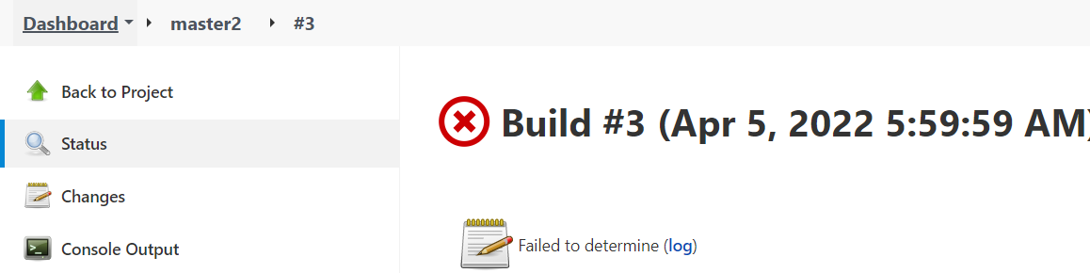 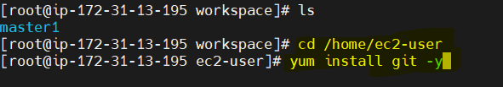 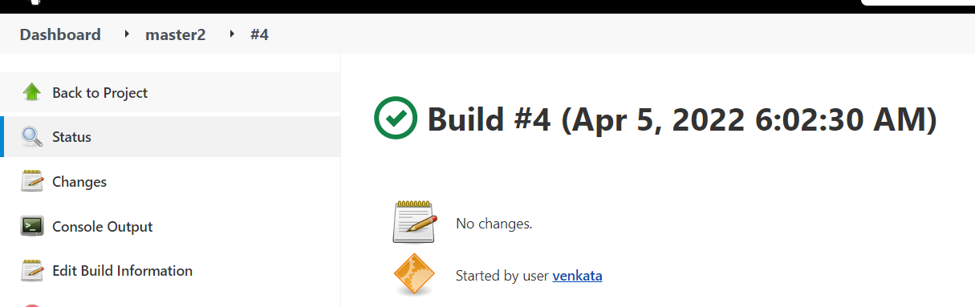

Maven install:-ex

. again we need to do build🡺configure🡺go to build🡺invoke top level maven targets(clean package)🡺apply and save🡺build now🡺build is fail🡺because they don’t need install maven, so we need to install maven packages on slave server🡺build success.

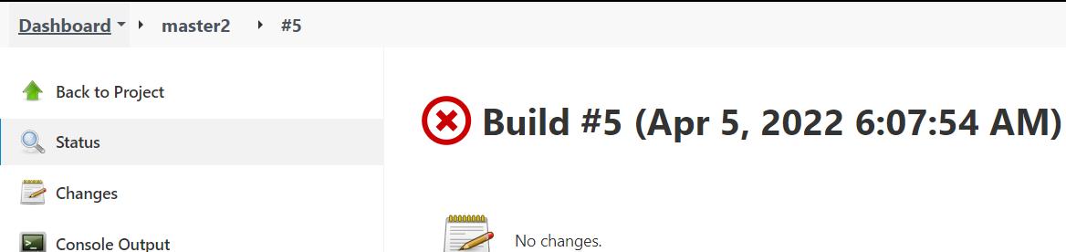

 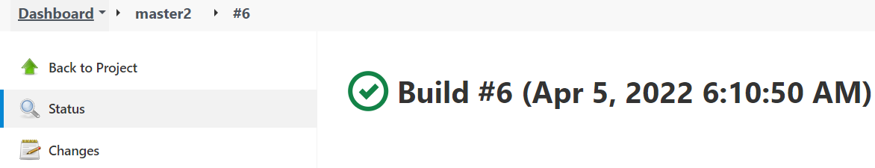

Tomcat on slave:- (war file deploy on tomcat)

. install tomcat on slave

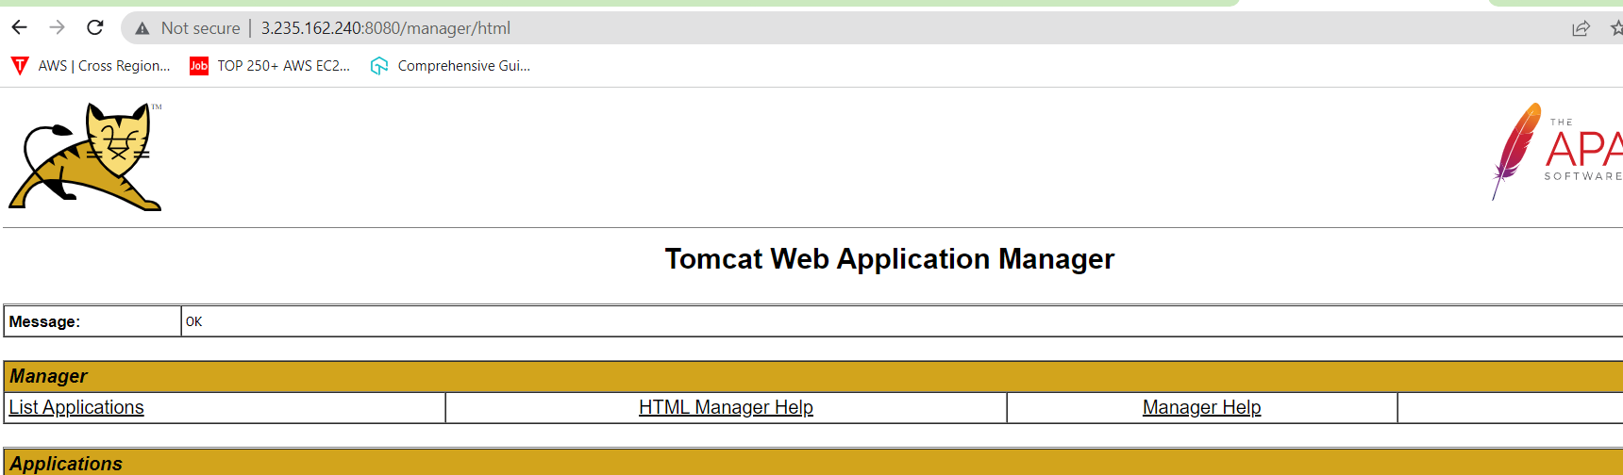

. We need to do an automation project which means we need a plugin.

. manage Jenkins🡺manage plugin🡺deploy to container plugin🡺install without restart.

. go to master2 job🡺configure🡺post-build actions 🡺below steps🡺apply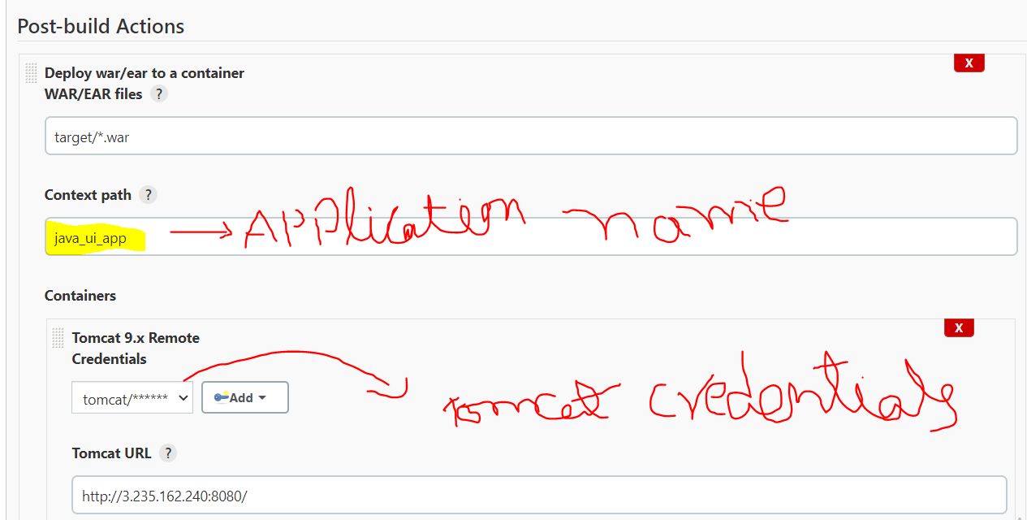

. build now🡺after build success🡺refresh on tomcat server.

